14th LAWASIA International Moot
Competition Structure and Schedule for National Rounds

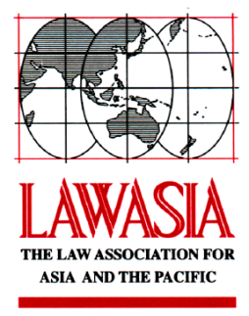
Organiser of the LAWASIA International Moot Competition

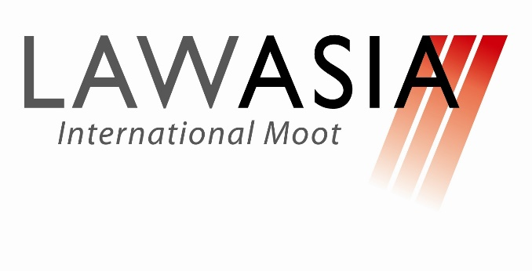
14TH LAWASIA INTERNATIONAL MOOT COMPETITION – NATIONAL ROUNDS
AUGUST 2019
KUALA LUMPUR, MALAYSIA

Registration/Ice Breaking : Friday, 23 August 2019
Moot Competition/Award Ceremony : Saturday, 24 August to Sunday, 25 August 2019

Team No.
UM  M1919 | MU  M1905 | UM  M1923 | TAYLORS  M1922 | UKM  M1908 | UITM  M1920
ATC  M1901 | IIUM  M1913 | UKM  M1916 | UITM  M1924 | UITM  M1915 | UM  M1914
UKM  M1921 | UITM  M1907 | ATC  M1911 | IIUM  M1903 | BAC  M1902 | TAYLORS  M1918
TAYLORS  M1910 | KDU  M1904 | UNISZA  M1909 | UNISZA  M1917 | UM  M1906 | BAC  M1912

Pre-Competition Day: Friday, 23 August 2019
Venue: Asian International Arbitration Centre (AIAC), Kuala Lumpur, Malaysia

Time | Event(s)
03:00pm – 03:30pm | Registration
03:30pm – 04:30pm | Briefing

Competition Day 1: Saturday, 24 August 2019 – Preliminary Round
Venue: Asian International Arbitration Centre (AIAC), Kuala Lumpur, Malaysia

Time | Event(s) C – Claimant; R - Respondent
07:30am–08:00am | Judge’s Briefing
Moot Room | A | B | C | D | E | F | G | H | I | J | K | L
08:00am–10:00am | M1919 (C)  v.  M1901 (R) | M1921 (C)  v.  M1910 (R) | M1905 (C)  v.  M1913 (R) | M1907 (C)  v.  M1904 (R) | M1923 (C)  v.  M1916 (R) | M1911 (C)  v.  M1909 (R) | M1922 (C)  v.  M1924 (R) | M1903 (C)  v.  M1917 (R) | M1908 (C)  v.  M1915 (R) | M1902 (C)  v.  M1906 (R) | M1920 (C)  v.  M1914 (R) | M1918 (C)  v.  M1912 (R)
10:00am–10:30am |  |  |  |  |  | Break
10:30am–12:30pm | M1912 (C)  v.  M1919 (R) | M1901 (C)  v.  M1921 (R) | M1910 (C)  v.  M1905 (R) | M1913 (C)  v.  M1907 (R) | M1904 (C)  v.  M1923 (R) | M1916 (C)  v.  M1911 (R) | M1909 (C)  v.  M1922 (R) | M1924 (C)  v.  M1903 (R) | M1917 (C)  v.  M1908 (R) | M1915 (C)  v.  M1902 (R) | M1906 (C)  v.  M1920 (R) | M1914 (C)  v.  M1918 (R)
12:30pm–02:00pm |  |  |  |  |  | Lunch
02:00pm–04:00pm | M1919 (C)  v.  M1922 (R) | M1924 (C)  v.  M1901 (R) | M1921 (C)  v.  M1903 (R) | M1917 (C)  v.  M1910 (R) | M1905 (C)  v.  M1908 (R) | M1915 (C)  v.  M1913 (R) | M1907 (C)  v.  M1902 (R) | M1906 (C)  v.  M1904 (R) | M1923 (C)  v.  M1920 (R) | M1914 (C)  v.  M1916 (R) | M1911 (C)  v.  M1918 (R) | M1912 (C)  v.  M1909 (R)
04:00pm–04:30pm |  |  |  |  |  | Break
04:30pm–06:30pm | M1909 (C)  v.  M1923 (R) | M1903 (C)  v.  M1911 (R) | M1916 (C)  v.  M1924 (R) | M1922 (C)  v.  M1917 (R) | M1904 (C)  v.  M1912 (R) | M1918 (C)  v.  M1907 (R) | M1913 (C)  v.  M1914 (R) | M1920 (C)  v.  M1905 (R) | M1910 (C)  v.  M1906 (R) | M1902 (C)  v.  M1921 (R) | M1901 (C)  v.  M1915 (R) | M1908 (C)  v.  M1919 (R)
Determining the winner of a match

In any given match, the Team receiving the greater number of six (6) available Round Points wins the match. If the two Teams have equal number of Rounds Points, the Team with the higher Team Raw Scores wins the match. If the two Teams have an equal number of Round Points and an equal Team Raw Score, the match is a draw.

Determining the team progressing into the next round

The top 12 teams, which is determined by the number of wins, from the Preliminary Rounds will proceed to the Semi-Final Round. Teams will be ranked from 1 to 12 based on number of wins in descending order.

In the case of a tie, the team with the higher accumulated Total Round Points in the Preliminary Round will be ranked higher. In the case that the tie is not broken, the Team with the higher Total Raw Score from the rounds shall be ranked higher. *

The 12 teams progressing to the next round will be assigned as listed in the Semi-Final Round structure.
* In the event, in any given round, if the methods of breaking the tie is unsuccessful, the Competition Administrator shall determine the next best method to breaking the tie.

Competition Day 2: Sunday, 25 August 2019 – Semi-Final and Final Round
Venue: Asian International Arbitration Centre (AIAC), Kuala Lumpur, Malaysia

Time | Event(s) C – Claimant; R - Respondent
07:30am–08:00am | Judge’s Briefing
Semi-Final Rounds
Moot Room | A | B | C | D |  | E |  | F
08:00am–10:00am | Team ranked 01 (C)  v.  Team ranked 12 (R) | Team ranked 02 (C)  v.  Team ranked 11 (R) | Team ranked 03 (C)  v.  Team ranked 10 (R) | Team ranked 04 (C)  v.  Team ranked 09 (R) |  | Team ranked 05 (C) v.  Team ranked 08 (R) |  | Team ranked 06 (C)  v.  Team ranked 07 (R)
10:00am–10:30am |  |  | Break
10:30am–12:30pm | Team ranked 12 (C)  v.  Team ranked 06 (R) | Team ranked 11 (C)  v.  Team ranked 05 (R) | Team ranked 10 (C)  v.  Team ranked 04 (R) | Team ranked 09 (C)  v.  Team ranked 03 (R) |  | Team ranked 08 (C) v.  Team ranked 02 (R) |  | Team ranked 07 (C)  v.  Team ranked 01 (R)
12:30pm–02:00pm |  |  | Lunch
Determining the winner of a match

In any given match, the Team receiving the greater number of six (6) available Round Points wins the match. If the two Teams have equal number of Rounds Points, the Team with the higher Team Raw Scores wins the match. If the two Teams have an equal number of Round Points and an equal Team Raw Score, the match is a draw.

Determining the team progressing into the next round

The top 2 teams, which is determined by the number of wins, from the Semi-Final Rounds will proceed to the Final Round. Teams will be ranked from 1 to 2 based on number of wins in descending order.

In the case of a tie, the team with the higher accumulated Total Round Points in the Semi-Final Rounds will be ranked higher. In the case that the tie is not broken, the Team with the higher Total Raw Score from the rounds shall be ranked higher.

If there is still a tie, the team that was ranked higher in the Preliminary Rounds will be ranked higher. *

The team ranked as no. 1 in the Semi-Final Rounds will be given the option to choose to moot as Claimant or Respondent in the Final Round.

Final Round
Moot Room | A
01:30pm–02:00pm | Judge’s Briefing
02:00pm–04:00pm | Team mooting as Claimant  v.  Team mooting as Respondent
* In the event, at any round, the methods of breaking the tie is unsuccessful, the Competition Administrator shall determine the next best method to breaking the tie.

Progression into the 14TH LAWASIA International Moot Competition – International Rounds

The team that wins the Final Round will be the Champion Team while the other finalist team will be the 1st Runner-Up Team. The 2nd Runner-Up Team and the 3rd Runner-Up Team will be determined from the rankings in the Semi-final Rounds.

The Champion Team will represent Malaysia in the LAWASIA International Moot Competition held in the same year. The 1st Runner-Up Team (the other team of the Final Round) will be the second team to represent Malaysia in the International Rounds provided the 1st Runner-Up Team is from a different institution to that of the Champion Team.

In the event that the 1st Runner-Up Team is from the same institution to that of the Champion Team, the 2nd Runner-Up will then be the second team to represent Malaysia in the International Rounds.

In the event that both 1st Runner-Up and 2nd Runner-up Teams are from the same institution to that of the Champion Team, the 3rd Runner-Up will then be the second team to represent Malaysia in the International Rounds.

The teams progressing into the International Rounds must be represented by the same members of mooters who participated in the National Rounds.

